Izvirni znanstveni članek / Original scientific article
The title should be consistent with the content of the article and up to 120 characters long

Key words: Key word 1; Key word 2; Key word 3; Key word 4; Key word 5

ABSTRACT (Abstract should not exceed 150–220 words.)
A structured abstract is an abstract which has individually outlined and labelled sections for quick reference. It is structured under the following headings:
Introduction: This section indicated the main question to be answered, and states the exact objective of the paper and the major variables of the study.
Methods: This section provides an overview of the research or experimental design, the research instrument, the reliability of the instrument, the place, methods and time of data collection, and methods of data analysis.
Results: This section briefly summarises and discusses the major findings. The information presented in this section should be directly connected to the research question and purpose of the study. Quantitative studies should include the statement of statistical validity and statistical significance of the results.
Discussion and conclusion: This section states the conclusions and discusses the research findings drawn from the results obtained. Presented in this section are also limitations of the study and the implications of the results for practice and relevant further research. Both positive and negative research findings should be adequately presented.

The article should not exceed 6,000, together with an abstract, tables, pictures and references.
A review article represents an overview of the latest publications in a specific subject area, the studies of an individual researcher or group of researchers with the purpose of summarising, analysing, evaluating or synthesising previously published information. Research findings are not only described but explained, interpreted, analysed, critically evaluated and presented in a scholarly manner. A review article presents either qualitative data processing of previous research findings (meta-analyses) or qualitative syntheses of previous research findings (meta-syntheses) and thus provides new knowledge and concepts for further research. The organisational pattern of a review article is similar to that of the original scientific article.
In the category of review scientific research are included: literature review, concept analyses, discussion- based articles (also referred to as a review article). The Slovenian Nursing Review publishes review scientific research, the data collection of which has been concluded a maximum of three years before article publication.
Introduction
The introduction section defines the scientific, conceptual or theoretical basis for the literature review. It also states the necessity for the review along with the aims, objectives and research question(s).
Method
The method section accurately defines the research methods by which the literature search was conducted. It is further subdivided into: review methods, results of the review, quality assessment of the review and description of data processing.
Review methods include the development, testing and search strategy, predetermined criteria for the inclusion in the review, the searched databases, limited time period of published literature, types of publications according to hierarchy of evidence, key words and the language of reviewed publications.
Results
The results of the review include the number of hits, the number of reviewed research studies, the number of included and excluded sources consulted. The results are presented in the form of a diagram of all the research stages of the review. International standards for the presentation of the literature review results may be used for this purpose (e.g. PRISMA - Preferred Reporting Items for Systematic Review and Meta-Analysis.
Quality assessment of the review and description of data processing includes the assessment of the research approach and data obtained as well as the quality of included research studies according to the hierarchy of evidence, and the data processing method.
The results should be presented in the form of a table and should include a quality analysis of the sources consulted. The table should include the author(s) of each study, the year of publication, the country where the research was conducted, the research purpose and design, the variables studies, the research instrument, sample size, the key findings, etc.
It should be evident which studies are included in the review according to the hierarchy of evidence. The results should be presented verbally and visually (tables and figures), the main findings concerning the research design should also be included. In qualitative synthesis, the codes and categories should be used as a result of the qualitative synthesis review. In quantitative analysis, the statistical methods of data processing of the used scientific works should be described.
The first section of the discussion answers the research question which is followed by the author's observations on literature review findings and the quality of the research studies included. The author evaluates the review findings in relation to the results from other comparable studies. The discussion section identifies new perspectives and contributions of the literature review, and their theoretical, scientific and practical application. It also defines research limitations and indicates the potential applicability of the review findings and suggests further research.

The tables should contain information organised into discrete rows and columns. They should be numbered sequentially with Arabic numerals throughout the document according to the order in which they appear in the text. They should include at least two columns, a descriptive but succinct title (above the table), the title row, optional row totals and column totals summarising the data in respective rows and columns, and, if necessary, notes and legends. No empty cells should be left in a table and the table size should not exceed 57 lines. Tables must conform to the following type: All tabular material should be 11pt font, Times New Roman font, single spacing, 0.5 pt spacing, left alignment in the first column and in all columns with the text, left alignment in the columns with statistical data, with no intersecting vertical lines. The editors, in agreement with the author/s, reserve the right to reduce table sizes. (example Table 1).
Table 1: Title of the table
Left alignment | $\overline{x}$$\overline{x}$ | R | Min | Max | s
Left alignment | 1 | 6 | a | b | b
Text | d | 7 | b | 1 | 1
Text | 3 | 8 | b | 2 | 2
Text | 4 | 9 | b | 3 | 3
Text | 5 | 10 | b | 4 | 4
Legenda/Legend: $\overline{x}$ –average, R –/ rank, Min –minimum, Maks – maximum, s – standard deviation
The figures should be numbered consecutively in the order first cited in the text, using Arabic numerals. Captions and legends shuld be given below each figure in Slovene and English, Times New Roman font, size 11. Figures refer to all illustrative material, including graphs, charts, drawings, photographs, diagrams. Only 2-dimensional, black-and-white pictures (also with hatching) with a resolution of at least 300 dpi (dot per inch) are accepted. If the figures are in a 2-dimensional coordinate system, both axes (x and y) should include the units or measures used. (example Figure 1).

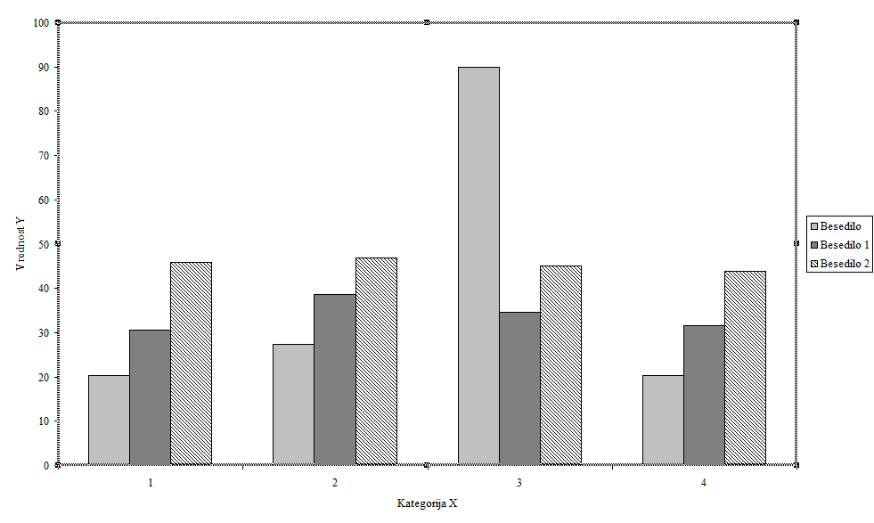
Figure 1: Title of the photo (Photo: Surname, Name.)

The total number of figures and tables should not exceed five. Tables and figures should be in the text of the article in the place where they belong. The author must refer to each table and figure in the text.
Conclusion
The conclusion section emphasises the contribution of the literature review conducted, sheds light on any gaps in previous research, identifies the significance of further research, the translation of new knowledge and recommendations into practice, research, education, management by also taking into consideration its limitations. It also pinpoints the theoretical concepts which may guide or direct further research. Citation of quotes, paraphrases or abbreviations should not be included in the conclusion.

References
In academic writing, authors are required to acknowledge the sources from which they draw their information, including all statements, theories or methodologies applied. Authors should follow the APA 7- American Psychological Association (APA Style, 2020) for in-text citations and in the list of references at the end of the paper. In-text citations or parenthetical citations are identified by the authors' surname and the publication year placed within parentheses immediately after the relevant word and before the punctuation mark: (Pahor, 2006) or Pahor (2006) when the surname is included in the sentence. For more than three authors in the text, write "et al." (separate two surnames with "&": (Stare & Pahor, 2010; Chen et al., 2007). If citing multiple works, separate them with semicolons and list them alphabetically, separated by a semi-colon (Bratuž, 2012; Pajntar, 2013; Wong et al., 2014).

Secondary sources should be referenced by 'cited in' (Lukič, 2000 as cited in Korošec, 2014). In citing a piece of work which does not have an obvious author or the author is unknown, the in-text citation includes the title followed by 'Anon.' in parentheses, and the year of publication: The past is the past (Anon., 2008). In citing a piece of work whose authorship is an organisation or corporate author, the name of the organisation should be given, followed by the year of publication (Royal College of Nursing, 2010). If no date of publication is given, the abbreviation 'n. d.' (no date) should be used: (Smith, n. d.). An in-text citation and a full reference should be provided for any images, illustrations, photographs, diagrams, tables or figures reproduced in the paper as with any other type of work: (Photo: Marn, 2009; source: Cramer, 2012). If a subject in the photo is recognisable, a prior informed consent for publication should be gained from the subject or, in the case of a minor, from their parent or guardian.

All in-text citations should be listed in the references at the end of the document. Only the citations used are listed in the references, which should arranged in alphabetical order according to authors' last names. In-text citations should not refer to unpublished sources. If there are several authors, the in-text citation includes only the last name of the first author followed by the phrase et al. and the publication date. We list up to 20 authors. In case there are more than 20 authors, we list 19, add a comma, three dots, and the last author. The list of references should be arranged in alphabetical order according to the first author's last name, character size 12pt with single spaced lines, left-aligned and with 12pt spacing after references (paragraph spacing). Cited pages should be included in the in-text citation if the original segment of the text is cited (Ploč, 2013, p.56) and in the references (see examples). If several pages are cited from the same source, the pages should be separated by a comma (e.g. pp. 15–23, 29, 33, 84– 86). If a source cited is also accessible on the World Wide Web, the bibliographic information should conclude with 'Retrieved from', date, followed by the URL- or URN-address (See examples).

Authors are advised to consult articles on the topic of their manuscript which have been published in previous volumes of our journal (over the past five-year period). Other examples of citations and references are available at https://apastyle.apa.org and Guide for authors and reviewers.

